Acceptance Conformity for Radar 5 77GHz G1.2&G1.3 VS412

Applicable for all Radar 77GHz Product
Fixture No.:EPT-RDR04G1.2-06-01

RESTRICTED ACCESS

DISTRIBUTION :
Firm Recipient Copies
CFM James Nie 1
CFM Cecilia Xia 1
CFM Daniel Wang 1
CFM Steven Wu 1

REVISION

Revision Date Author Comments

A 2022-11-29 James Nie Initial Release

CONTENTS

1. REFERENCE 4
2. OBjective 4
3. Method of measurement 5
4. List of the ACCEPTANCE CRITERIA for Radar 5 77GHz VS412 5
5. Conclusion 5

REFERENCE

Trial date : 2022/11/29

Trial done by : James Nie

Station of Test: Radar 5 77GHz VS412 Station

Fixture: EPT-RDR04G1.2-06-01

OBjective
Verify the conformity of the Radar 5 77GHz VS412 with the production requirements and validate it can be used for production.

Radar 77GHz VS412 as below：
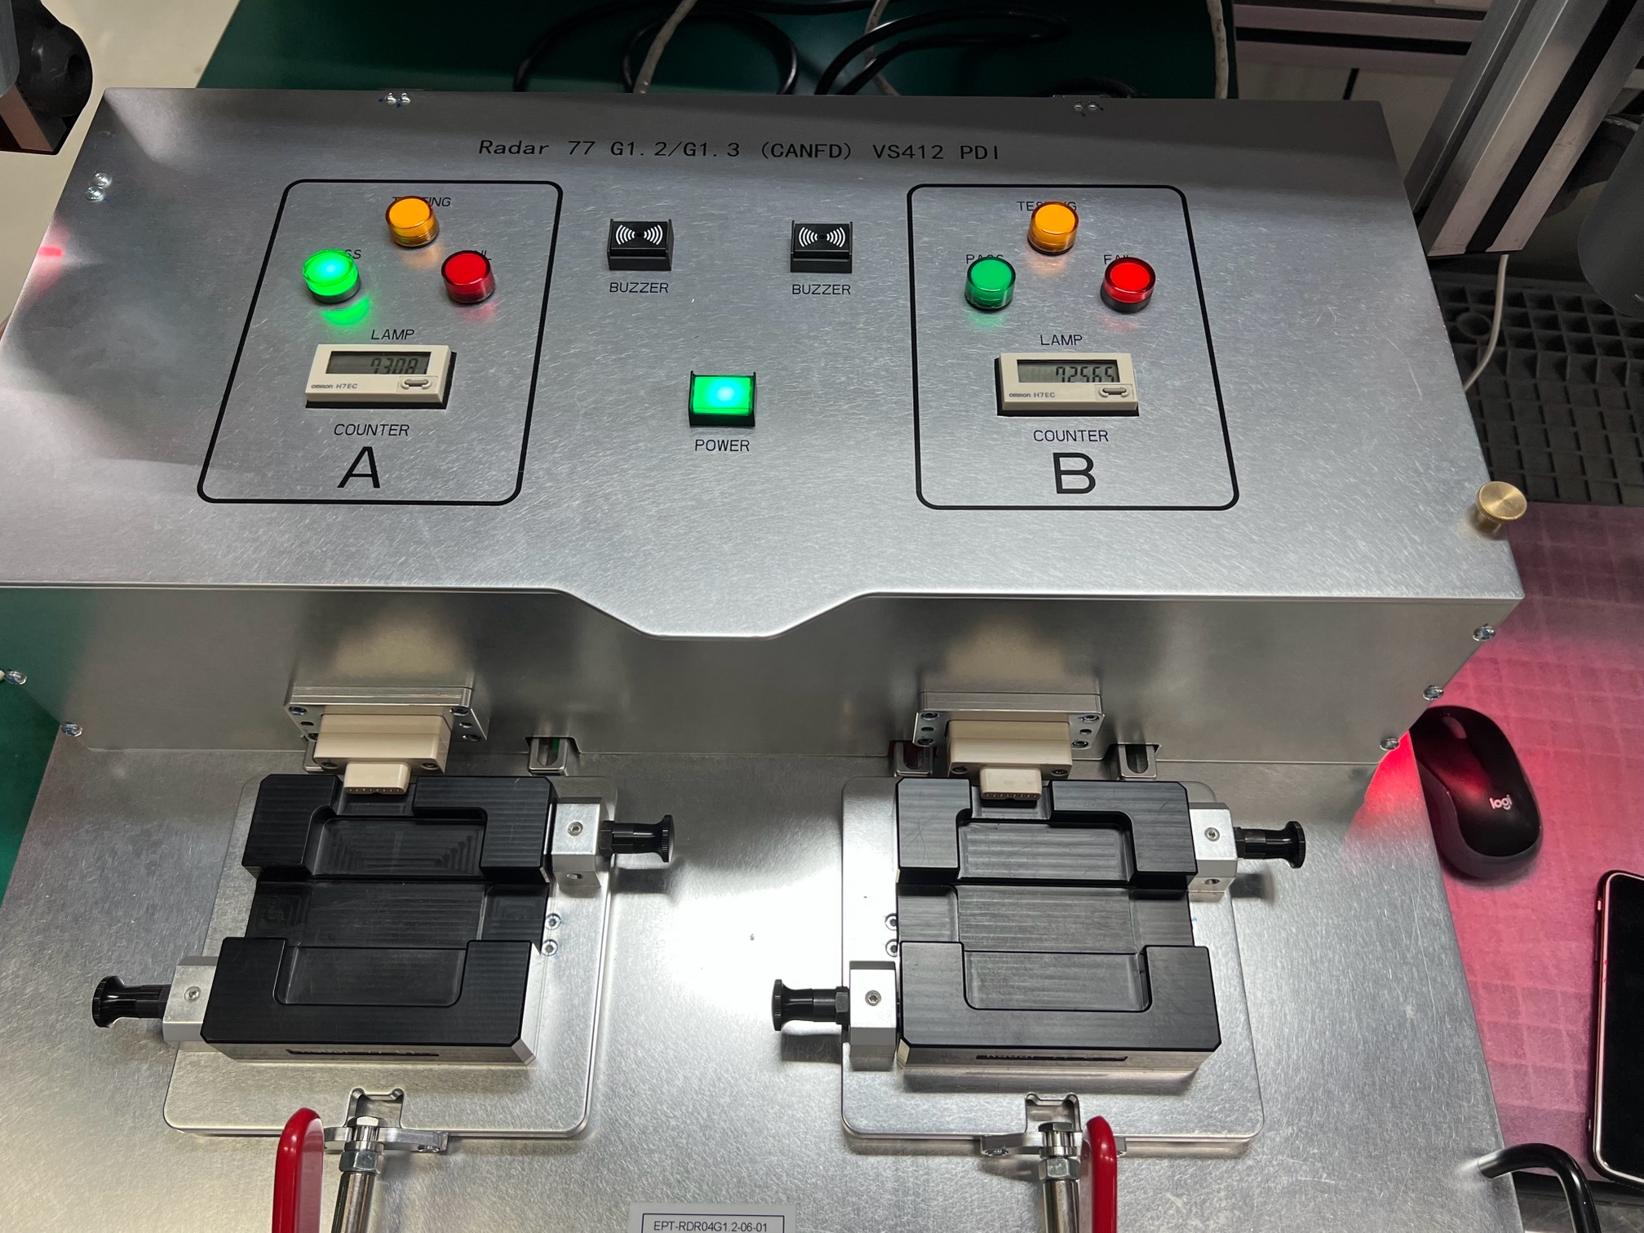
.

Method of measurement
The acceptance criteria has been defined and listed for the Radar 5 VS412 and that will be verified with the test system to meet the acceptance criteria.

List of the ACCEPTANCE CRITERIA for Radar 5 77GHz VS412
See the attached file.

ACCEPTANCE CRITERIA for Radar 5 77GHz VS412

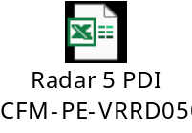

Conclusion
The Radar 5 77GHz VS412 is conformed to meet the acceptance criteria and production requirements.

